**Command1.sh**

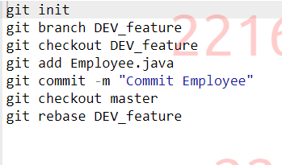

**Employee.java**

**Driver.java**

